SHIELD TECH SECURITY

FAI-320 and FAI-586 DIAGRAMS

www.shieldtechsecurity.com (Revision 1.1)

CONNECTING FAI-320 to FAI-586 DIAGRAM

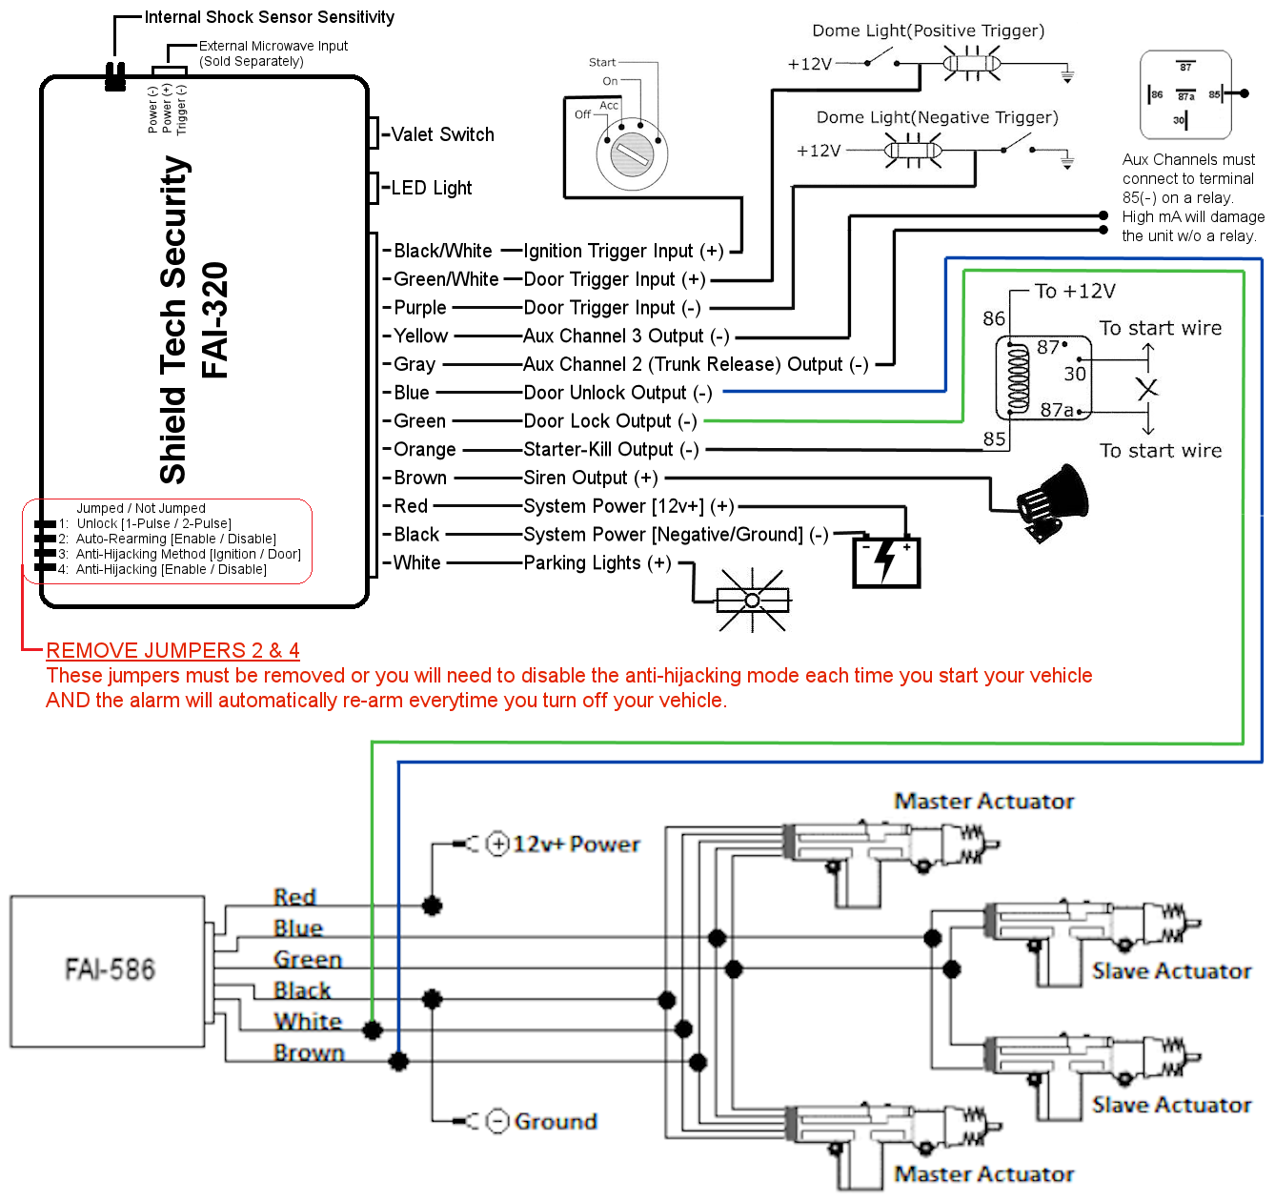

FAI-320 WIRING DIAGRAM

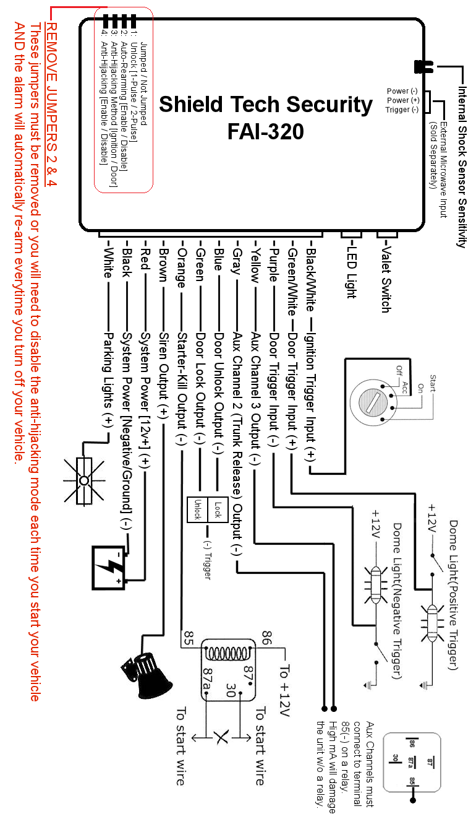

FAI-586 WIRING DIAGRAM

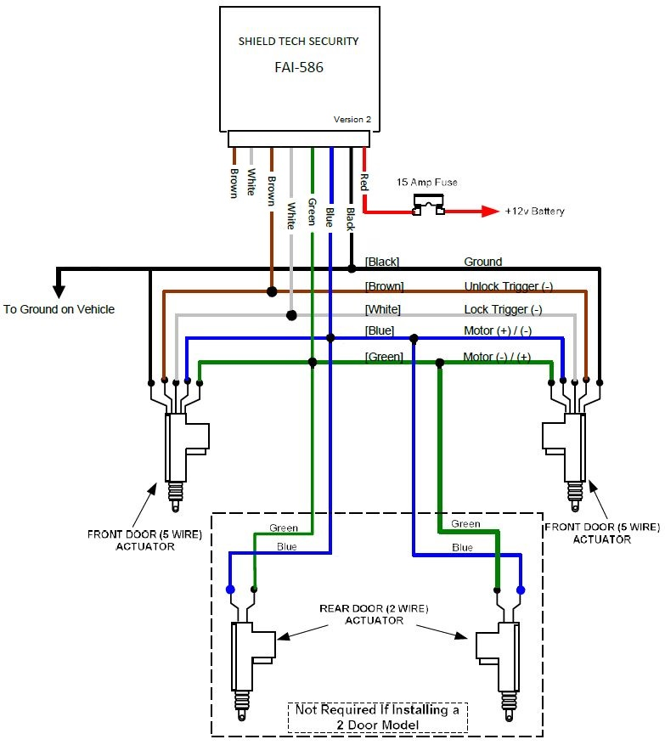

MORE INFORMATION

Please visit www.shieldtechsecurity.com for more information.

